**LAB 6**

**AIM: Analysis of effect of applying different filters on the image to give it a blur**

**effect (Smoothing Filters).**

**1. Take any of your grey scale photo and blur it with standard box filter of size**

**3x3, 5x5, 7x7 and 9x9.**

**a. Perform the blurring process without using inbuilt functions.**

**b. Compare the results with the results obtained using in built functions like**

**imfilter and conv2.**

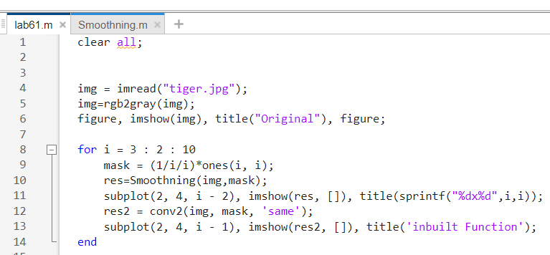

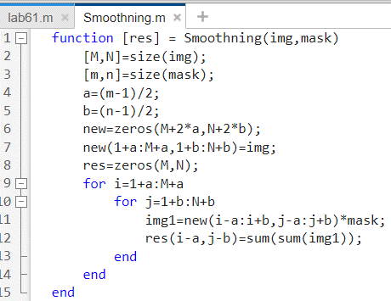

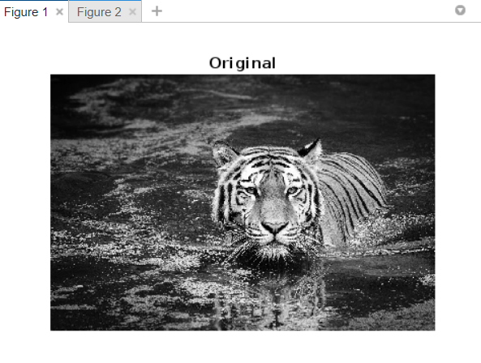

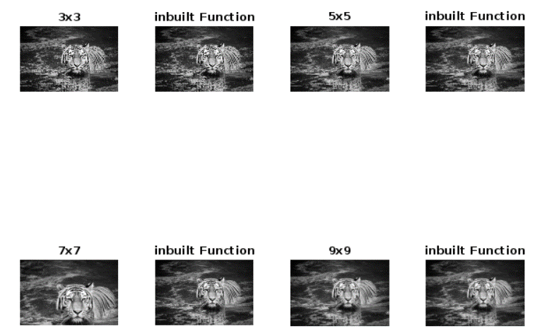

**2. Take any of your gray scale photo and blur it with weighted average filter.**

**Compare amount of blurring with the standard box filter of the same size.**

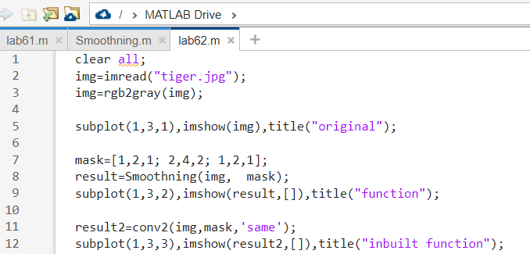

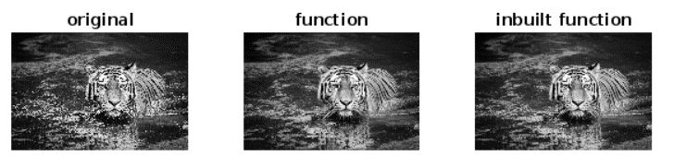

**3. Show the impact of multiple passes of the smoothing filter of same size. Derive**

**your conclusion on image quality and maximum number of passes of filter?**

**What happens if infinite number of passes are applied? Will it change image**

**quality?**

